**Autonomous underwater vehicle for sea water intake**

**tunnel inspection and cleaning for nuclear plant**

Report submitted to GITAM (Deemed to be University) as a partial fulfillment of the requirements for the award of the Degree of Bachelor of Technology in (write your respective branch)



DEPARTMENT OF ELECTRICAL, ELECTRONICS AND COMMUNICATION ENGINEERING

GITAM SCHOOL OF TECHNOLOGY

GITAM (DEEMED TO BE UNIVERSITY)

BENGALURU -561203

NOV 2025

**Name:1)Polisetty Karthik (BU22EECE0100334)**

**2)N Uday Mahesh Teja (BU22EECE0100456)**

**DECLARATION**

I/We declare that the project work contained in this report is original and it has been done by me under the guidance of my project guide.

Name:

1) **Polisetty Karthik**

2) **N Uday Mahesh Teja**

Date: Signature of the Student

**Department of Electrical, Electronics and Communication Engineering GITAM School of Technology, Bengaluru-561203**



**CERTIFICATE**

This is to certify that (Student Name) bearing (Regd. No.:) has satisfactorily completed Mini Project Entitled in partial fulfillment of the requirements as prescribed by University for VIIth semester, Bachelor of Technology in “Electrical, Electronics and Communication Engineering” and submitted this report during the academic year 2025-2026.

[Signature of the Guide] [Signature of HOD]

**Table of contents**

**Chapter 1: Introduction 1**

* 1. Overview of the problem statement 1
  2. Objectives and goals 1

**Chapter 2 : Literature Review 2**

**Chapter 3 : Strategic Analysis and Problem Definition 3**

* 1. SWOT Analysis 3
  2. Project Plan - GANTT Chart 3
  3. Refinement of problem statement 3

**Chapter 4 : Methodology 4**

* 1. Description of the approach 4
  2. Tools and techniques utilized 4
  3. Design considerations 4

**Chapter 5 : Implementation5**

* 1. Description of how the project was executed 5
  2. Challenges faced and solutions implemented 5

**Chapter 6: Results 6**

* 1. outcome 6
  2. Interpretation of results 6
  3. Comparison with existing technologies 6

**Chapter 7: Conclusion 7**

**Chapter 8 : Future Work 8**

**References 9**

**Chapter 1: Introduction**

* 1. Overview of the problem statement

Nuclear power plants rely on seawater intake systems to cool their reactors and other equipment. These systems are critical to the safe and efficient operation of the plant. However, the seawater intake tunnels can become clogged with debris, sedimentation, and other obstructions, which can reduce the efficiency of the cooling system and potentially lead to safety issues. Traditional inspection and cleaning methods can be time-consuming, expensive, and pose risks to human divers. To address these challenges, this project proposes the design and development of an Autonomous Underwater Vehicle (AUV) using Arduino for inspecting and cleaning seawater intake tunnels in nuclear plants. The AUV will be equipped with advanced sensors, navigation systems, and cleaning mechanisms, enabling it to navigate through the tunnels, detect debris and sedimentation, and perform cleaning operations. The use of Arduino technology will enable the AUV to operate autonomously, reducing the need for human intervention and minimizing the risks associated with traditional inspection and cleaning methods. The AUV will be designed to operate in a variety of water conditions, including varying temperatures, depths, and currents. By developing an AUV specifically designed for seawater intake tunnel inspection and cleaning, this project aims to improve the safety, efficiency, and reliability of nuclear plant operations. The AUV will help to ensure the optimal flow of cooling water, reduce maintenance costs, and minimize the risk of accidents or injuries.

* 1. Objectives

• Inspect seawater intake tunnels: Use sensors and cameras to detect debris, sedimentation, or other issues that may affect the tunnel's functionality.

• Clean seawater intake tunnels: Utilize cleaning mechanisms or tools to remove debris and sedimentation, ensuring optimal water flow.

• Navigate through tunnels: Develop navigation algorithms and control

systems to enable the AUV to maneuver through the tunnels

efficiently.

• Collect data: Gather data on water quality, flow rates, and tunnel conditions using various sensors, such as temperature, pH, and pressure sensors.

• Autonomous operation: Autonomous control and navigation, minimizing human intervention.

Goals

• Robust Communication: Establish reliable communication systems to transmit data and control commands between the AUV and the surface.

• Reduced Downtime: Minimize downtime and maintenance costs by automating inspection and cleaning tasks.

• Reliable Inspection: Conduct thorough inspections of seawater intake tunnels to detect potential issues, such as debris, sedimentation, or damage.

**Chapter 2: Literature Review**

1)

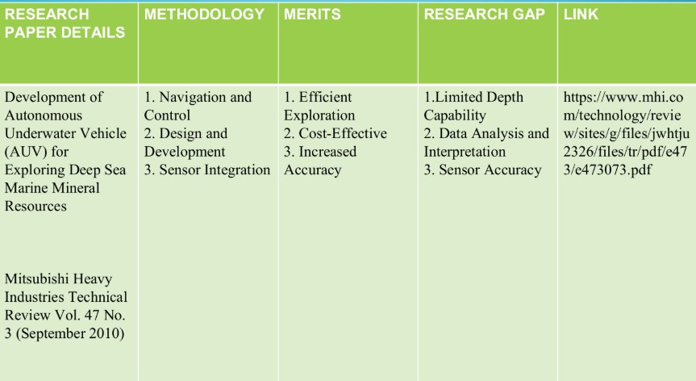

2)

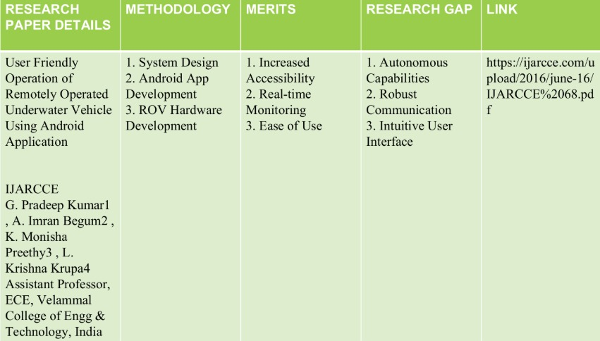

3)

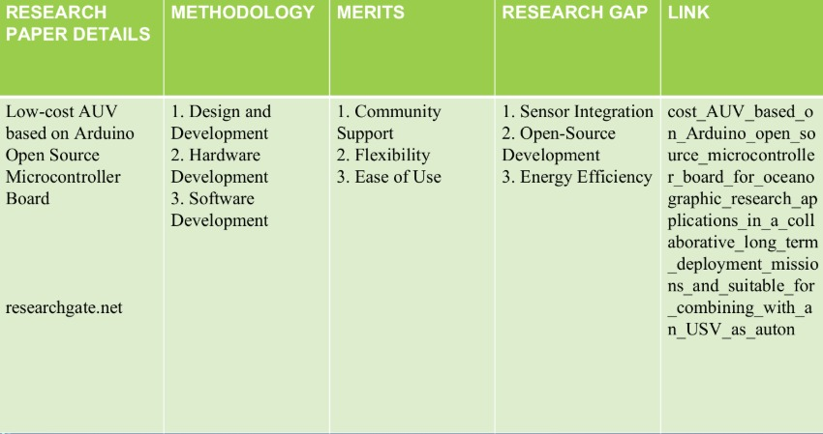

**Chapter 3 : Strategic Analysis and Problem Definition**

* 1. SWOT Analysis
  2. Project Plan - GANTT Chart
  3. Problem statement

**Chapter 4 : Methodology**

* 1. Description of the approach

The methodology to build an Autonomous Underwater Vehicle (AUV) for seawater intake tunnel inspection and cleaning in a nuclear plant involves a systematic, multi-phase approach starting with requirement analysis and site assessment to define tunnel geometry, water conditions, safety, and regulatory constraints. The next step is conceptual design, where the AUV’s structure, propulsion, power system, sensors (cameras, sonar, DVL, IMU), and cleaning tools (brushes, water jets, suction units) are selected to ensure efficient operation in confined, low-visibility environments. This is followed by detailed design and prototyping, including CAD modeling, control system development, and sensor integration. The integrated prototype is then tested in controlled water tanks and mock tunnels to validate navigation accuracy, inspection imaging, and cleaning efficiency while ensuring fail-safe operation and decontamination compliance. Finally, field trials are conducted in actual plant conditions to fine-tune autonomy, communication, and reliability before full deployment for periodic inspection and cleaning of seawater intake tunnels.

* 1. Tools and techniques utilized

To implement and test the system, the following tools and techniques were used:

1.CAD and simulation software (like SolidWorks, ANSYS, or MATLAB Simulink) for mechanical design, hydrodynamic modeling, and structural analysis;

2.Pressure-resistant hull fabrication tools for assembling corrosion-resistant enclosures using materials such as stainless steel or titanium;

3.Embedded control systems and microcontrollers/ROS-based platforms for real-time navigation, autonomy, and data processing;

4.Sensor integration techniques combining sonar, cameras, IMU, and DVL for precise localization and mapping in turbid, GPS-denied environments;

5.SLAM (Simultaneous Localization and Mapping) and image-processing algorithms for tunnel mapping and defect detection;

6.Cleaning tool systems such as rotary brushes, controlled-pressure water jets, and suction mechanisms designed for biofouling removal without surface damage;

7.Testing and calibration setups like water-tank mock tunnels for validating propulsion, buoyancy, and inspection performance; and

8.Data acquisition and analysis tools for logging inspection data, monitoring AUV health, and generating maintenance reports compliant with nuclear-safety standards.

* 1. Design considerations

During the design of the adaptive modulation scheme, the following considerations were taken into account:

1.Structural and Material Selection: The AUV must be compact, pressure-resistant, and made from corrosion-resistant, non-contaminating materials such as stainless steel or titanium to withstand seawater and allow easy decontamination in a nuclear environment.

2.Navigation and Control System: The AUV should include reliable sensors like DVL, IMU, sonar, and cameras for precise localization and autonomous navigation in GPS-denied, low-visibility tunnels with stable control and obstacle avoidance.

3.Power and Propulsion Design: Efficient thrusters and hydrodynamic design are essential to ensure smooth movement, low power consumption, and sufficient endurance for long tunnel inspections while maintaining maneuverability in confined spaces.

4. Inspection and Cleaning Mechanisms: The AUV must integrate modular tools such

as cameras, ultrasonic sensors, brushes, and controlled water jets to perform detailed

inspection and cleaning without damaging tunnel walls or coatings.

5. Safety and Fail-Safe Mechanisms: The system should include emergency recovery, communication redundancy, buoyancy control, and radiation-safe components to ensure safe operation and easy retrieval in case of malfunction within the nuclear plant environment.

**Chapter 5 : Implementation**

* 1. Description of how the project was executed
  2. Challenges faced and solutions implemented

**Chapter 6: Results**

* 1. outcomes
  2. Interpretation of results
  3. Comparison with existing literature or technologies

**Chapter 7: Conclusion**

Here write Suggestions for further research or development and Potential improvements or extensions

**Chapter 8 : Future Work**

Here write Suggestions for further research or development Potential improvements or extensions

**References**

Bengaluru City Office No 5/1, First Floor, Prestige Terraces, Union Street, Infantry Road, Bengaluru - 560003 Karnataka, India

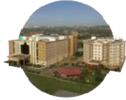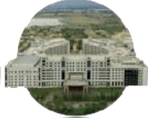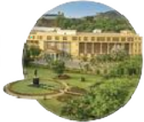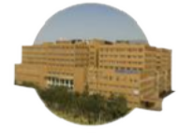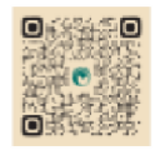

**GIMSR**

GITAM Medical College Rd, Gandhi Nagar, Rushikonda, Visakhapatnam - 530045 Andhra Pradesh, India